MSE-1 Devops
Prakhar Srivastava
CSE-D 5th Sem
202401100200228

Github Repo URL : https://github.com/PrakharSrivastava2408/github-skills-challenge
Pull request URL used to validate the workflows: https://github.com/PrakharSrivastava2408/github-skills-challenge/pull/4

Screenshot showing the GitHub Actions workflows:

Workflow 1:
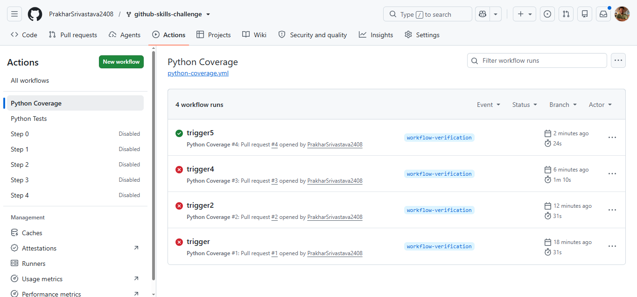

Workflow 2:
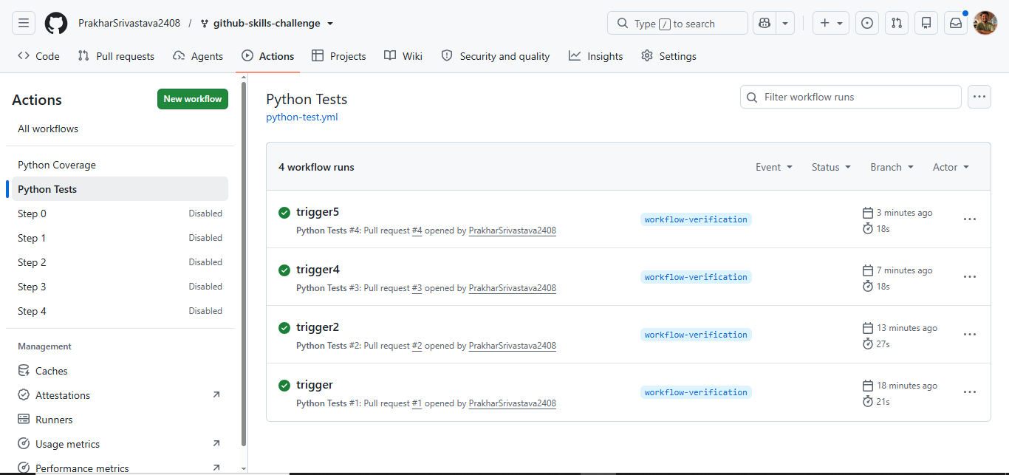

Screenshot showing a successful test workflow execution
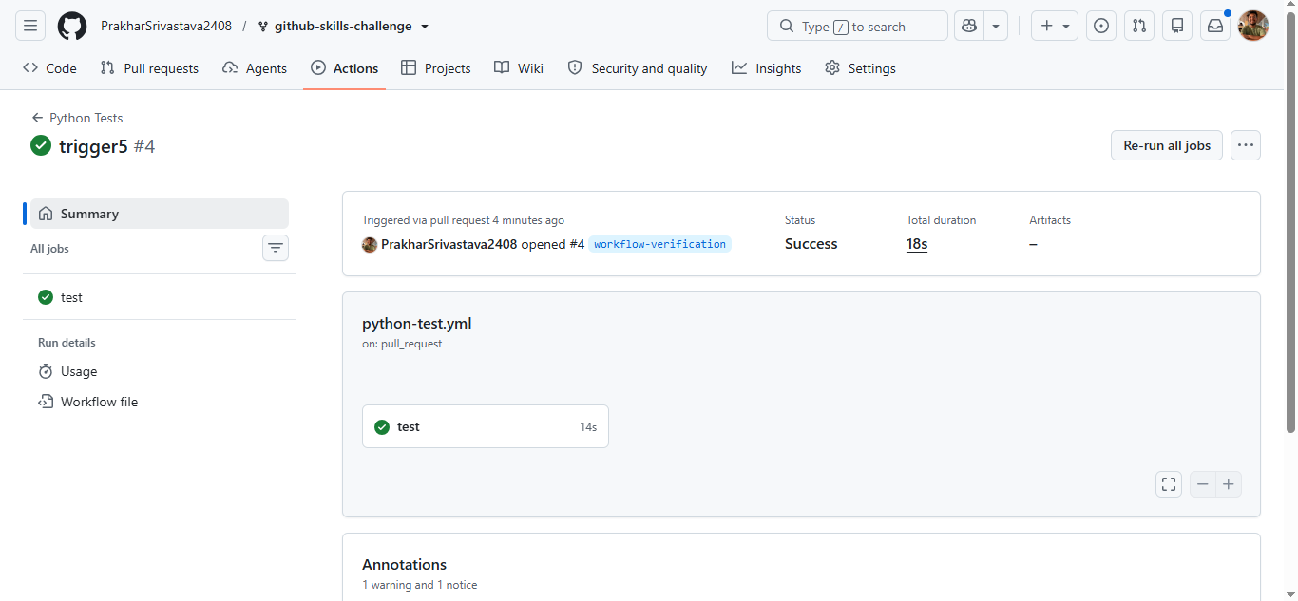

Screenshot showing the coverage result/comment on the pull request:
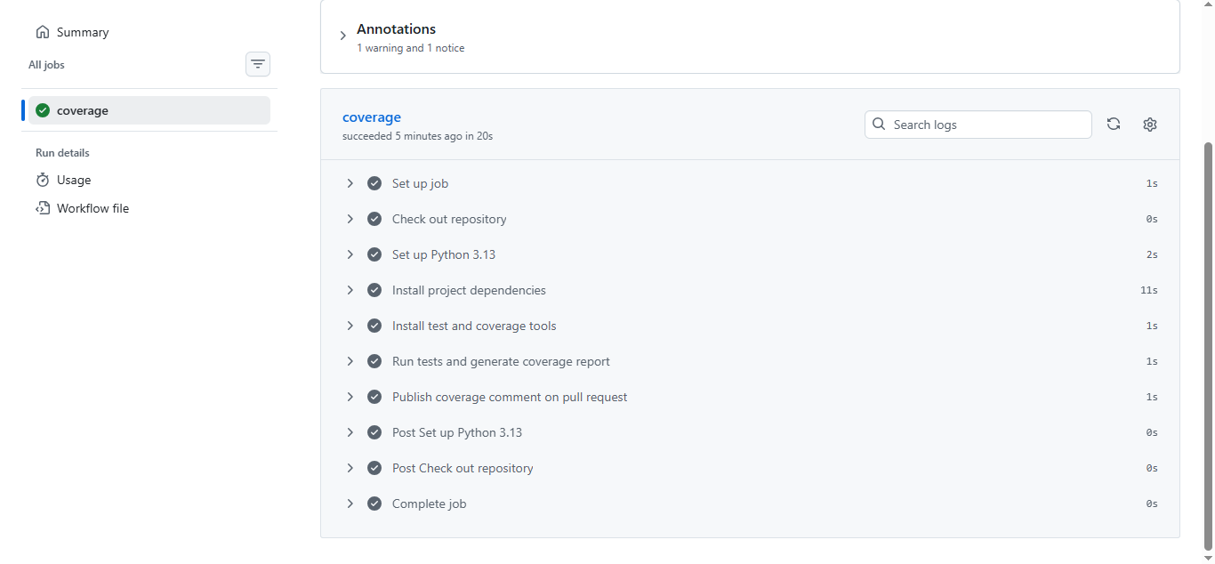

Screenshot showing the final repository/workflow files:

